**Rolling Homework #1**

**Problem 1:**

Adjacency matrix:

* $n x n$ (square) matrix where n is the number of vertices in the graph
* Undirected graphs are symmetrical along the diagonal whereas directed are not
* Edge represented by 1 at position $(i,j)$ else it is 0
* If graph is weighted position $(i, j)$ holds the weight instead of 1 or 0

Incidence matrix:

* $n x m$ (rectangular) matrix where n is the number of vertices in the graph and m is the number of edges in the graph
* Undirected graphs use 0 and 1 to represent which edges connect to which verity
* Directed graphs use -1 and 1 to represent the direction of an edge where -1 is the tail of the edge and 1 is the head
* Weighted incidence matrices are represented by replacing -1 and 1 by their respective weights for directed graphs; replace 1 if undirected

**Problem 2:**

The diameter of the graph is 14 To get 14, I used this python code; the .py file is also attached in the homework submission:

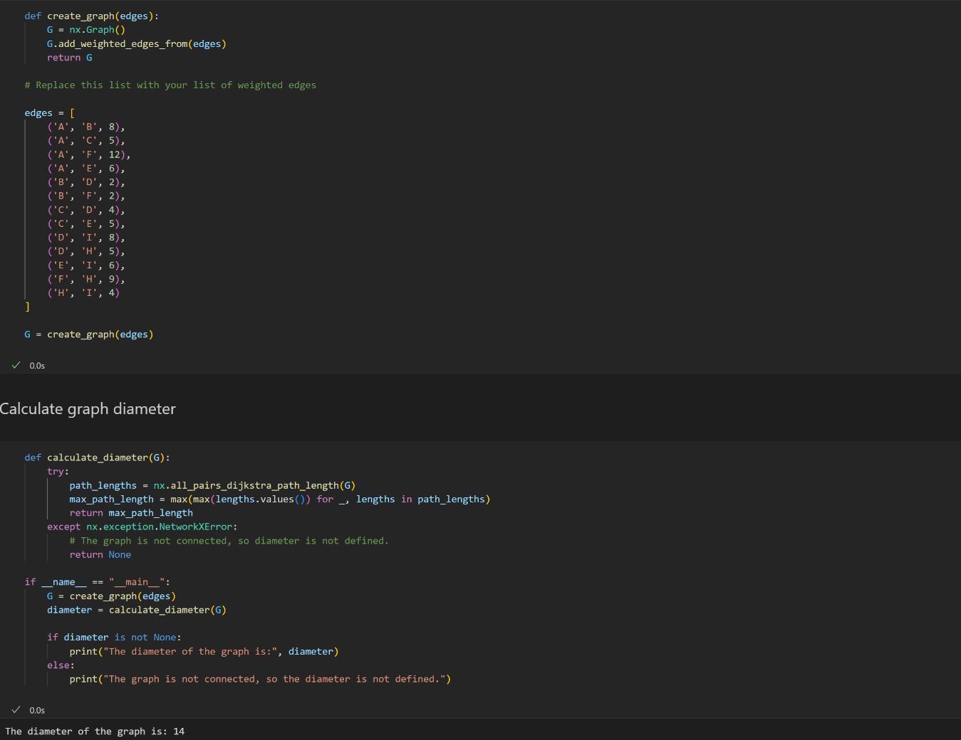

**Problem 3:**

*Retrieve the names of the customers who have purchased chocolate:*

match (u:User)-[:COMPLETED]->(o:Order)<-[:CONTAINS]-(i:Item)

where i.item_name = "chocolate"

return u.name

*Retrieve the email addresses and the credit card numbers of customers who have purchased beer:*

match (e:Email)-[:SignedUpWith]->(u:User)-[:Registered]->(c:CreditCard)-[:PaidUsing]->(o:Order)<-[:Contains]-(i:Item)

where i.item_name = "beer"

return e.e-address, c.cc_number

**Rolling Homework #2**

**Problem 1:**

* **Question 1:**

SELECT P.pID, P.p-city, W.cID

FROM Person P

JOIN Works-for W ON P.pID = W.pID

JOIN Company C ON W.cID = C.cID

JOIN Building B1 ON P.p-address = B1.b-address AND P.p-city = B1.b-city

JOIN Building B2 ON C.c-address = B2.b-address AND C.c-city = B2.b-city

WHERE P.age > 35

AND P.p-city = C.c-city

AND ST_Distance(ST_Centroid(B1.floorPlan), ST_Centroid(B2.floorPlan)) < 5*1609.34; --5 miles to meters

* **Question 2:**

SELECT R.rID

FROM RoadNet R

JOIN Cities C ON ST_Intersects(R.segments, C.cityBoundary)

WHERE R.category = 'highway'

AND (

SELECT SUM(ST_Area(B.floorPlan))

FROM Stores S

JOIN Building B ON S.s-address = B.b-address AND S.s-city = B.b-city

WHERE S.s-city = C.cityName

) > 5*2589988.1103; --5 square miles to square meters

**Problem 2:**

